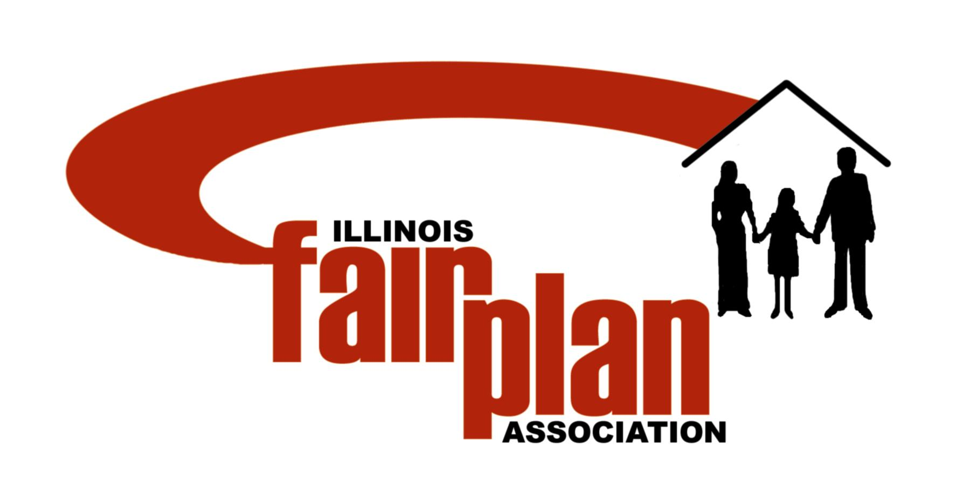

March 18, 2019

To: Member Companies of Illinois FAIR Plan Association

Re: Financial Reports for the Period Ended November 30, 2019

The following financial reports for the third quarter can be found at www.pipso.com.

Balance Sheet
Income Statement
Financial Download

Your share of the operating results should be recorded as direct business. The Illinois FAIR Plan Association pays Fire Marshal Taxes on behalf of the member companies; however, we do not pay premium taxes.

Assessment Update:

- The Illinois FAIR Plan did not issue an assessment in 2019,2018, 2017, 2016, 2015, 2014 or 2013. In June of 2011 the Illinois FAIR Plan issued an assessment for $4,158,769. In June of 2012 the Illinois FAIR Plan issued an assessment for $5,564,797.

- We issue quarterly financial statements that are available on our website and the PIPSO website. The Address, UserID and Password for our website and the PIPSO website are as follows:

Address: www.illinoisfairplan.com UserID: mem73co Password: il%M3mb3r307

Address: www.pipso.com UserID: pipsodata Password: bost27ma

If you have any questions, please contact Snehal Pandya at (312) 861-0385 Ext. 236.


Sincerely,


Joseph A. Hathaway
General Manager

